Lost Dog
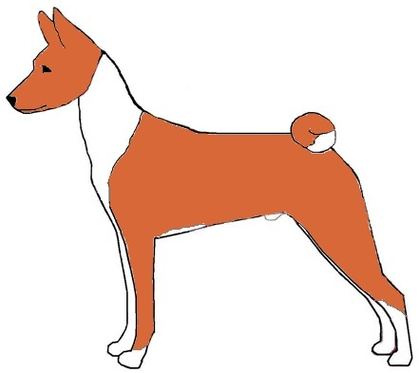
“XXXXXX”
CHESTNUT RED/WHITE MALE BASENJI DOG
REWARD
NO QUESTIONS ASKED.
Basenjis run very fast and are not afraid of cars.
DO NOT CHASE HIM… just call if you see her!
Wearing a BLUE collar with tags & microchip.
Last Seen: At 10am on Friday 12/19/14
Near (Location): At PetSmart in Bend, OR
Please Contact:
XXXX (000) 000-0000 or XXXX (000) 0000-0000

